**Isolation of Sulfate-Reducing Bacteria from Freshwater Sediment**

Jennifer Johnson and Joseph Schindler

*Microbiology Laboratory, Middlebury College, Middlebury, VT 05753*

Received 4 December 2017/Accepted 4 December 2017

**Sulfate-reducing bacteria (SRB) represent a diverse group of primarily chemoorganotrophic organisms that commonly contributes to industrial inefficiencies due to the production of iron precipitates in plumbing and machinery.  SRB are characterized by their utilization of sulfate (SO42-) as a terminal electron acceptor for bioenergetic energy conservation. In concert with sulfur-oxidizing bacteria, SRB contribute a key role in the sulfur cycle by reducing sulfate, the most oxidized form of sulfur, to its most reduced form, sulfide (S2-), which is released as H2S gas. In this study,  freshwater sediment was used to establish a Winogradsky column to enrich SRB. Sedimentary samples were extracted and cultured under conditions that mimic the anaerobic, high sulfate environments that promote SRB growth *in situ*. After initial anaerobic culture, SRB colonies appeared black due to iron sulfide precipitation, and were used to prepare pure cultures. Confirmation of SRB included determining the oxygen profile, gram reaction, and further biochemical analyses. This work contributes to our understanding of the laboratory culture of SRB and is significant because it could inform methods of treating wastewater or industrial equipment contaminated with SRB, mitigating damage from the iron precipitate they promote.**

**___________________________________________________**

**INTRODUCTION**

Sulfate-reducing bacteria (SRB) constitute a group of diverse, primarily chemoorganotrophic microorganisms.  Sulfur, present in abundance in the anoxic primordial Earth, can assume a wide range of oxidation states from its most oxidized form, sulfate (SO42-), to its most reduced form, hydrogen sulfide (H2S).  Due to the availability of sulfur and its redox versatility, early microbes utilized sulfur chemistry to drive metabolic processes.  This is exemplified by the SRB, which produce a proton motive force to drive production of ATP through the reduction of sulfate to hydrogen sulfide.  This is then released as a waste product of the dissimilatory sulfate reduction pathway.  SRB are anaerobic because oxygen is not the final electron acceptor (1). However, a small number of species may be tolerant of some levels of oxygen, and hence are aerotolerant. Because of their chemical requirements, SRB are commonly found in freshwater sediments, sewage, and other environments with a high concentration of sulfate and a low concentration of oxygen, including the human oral cavity (2).

Research primarily on members of the genus *Desulfovibrio* has elucidated many of the key metabolic processes in SRB.  An electron transport chain consisting of cytochromes, flavoproteins, and iron-sulfur proteins is used to generate a proton gradient across the bacterial cell membrane.  Most SRB are chemoorganotrophs that utilize electrons from diverse sources that vary greatly, but commonly include lactate or pyruvate.  Chemolithotrophic SRB utilize hydrogen gas as electron donors (3). The terminal electron acceptor is sulfate from environmental sources.  Sulfate is first reduced to sulfite (SO32-), a process that requires ATP hydrolysis.  Sulfite is next reduced to sulfide (S2-), which is released as hydrogen sulfide, utilizing a second molecule of ATP.  This post-electron-transport-chain reductive process incorporates eight electron transfers, uses two molecules of ATP, and is catalyzed by four enzymes (4).  ATP is ultimately synthesized through the dissipation of the proton motive force as protons move down their concentration gradient through an ATP synthase integral protein.

SRB have evolved along with the sulfur-oxidizing bacteria and contribute greatly to the balance of sulfur, sulfate, and sulfide in the sulfur cycle (5). In deep layers of sediment, sulfur compounds are present at low concentrations. Therefore, interdependence between SRB and sulfur-oxidizing bacteria evolved to ensure each group has access to enough of its required resource, which is produced by the other (6). The study of SRB is thus an examination of the coevolution of two groups. Furthermore, an understanding of the resulting metabolic interdependence is essential for the successful cultivation or removal of these organisms.

The study of SRB also has numerous industrial applications. SRB are present in hydrothermal vents, and therefore can have impacts on the oil and gas industries (7). Because one byproduct of sulfate reduction is hydrogen sulfide, which can react with sources of iron in machinery to form a precipitate, SRB can cause industrial inefficiencies (8). They also thrive in industrial wastewater. The contamination of the environment or equipment with the precipitate, black color, or hydrogen sulfide smell makes the study and control of SRB a priority for many industries. Estimates of the industrial damage construed by SRB to iron equipment corrosion and reduction in heat transfer efficiency has risen from $600 million annually in 1985 (adjusted for inflation) to several billion dollars annually at the present time, signifying that SRB biocorrosion is a major economic hindrance to industry that has not yet received an adequate solution (9, 10).

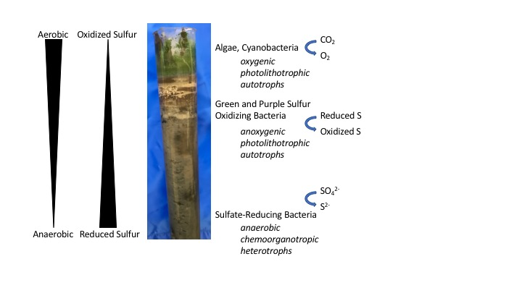

**Figure 1- Winogradsky Column Produced Enriched SRB Growth**

A Winogradsky column was established from fresh pond sediment and water. After ten weeks of growth at room temperature with abundant sunlight, sediment from the bottom of the column was extracted and used to inoculate crude cultures. Major classes of organisms are listed for enriched zones that contribute to the sulfur and oxygen gradients, with major metabolic conversions designated by curved arrows. Annotations adapted from Allen and Spatafora (11).

Furthermore, although SRB may be slow growing, they are able to withstand unfavorable conditions. Some species even form endospores and can therefore exist in a dormant state during anti-SRB treatment (4). The study of SRB and how to remove them from an environment is a challenging priority for oil industries and water treatment plants that warrants further attention.

This project centers on isolation of SRB from environmental samples of freshwater sediment, where SRB contribute a key role to the sulfur cycle as described above.  Although SRB thrive in a multitude of environments, this source was selected as a common habitat of SRB in the state of Vermont.  Moist sediments contain abundant sulfates and potentially low concentrations of oxygen, suitable conditions for the growth of SRB.  After extraction of sediments and surrounding fresh pond water, SRB were enriched in a Winogradsky column.  Winogradsky columns represent pond cross-sections and self-sufficient ecosystems in which organisms in the sealed column form microenvironments based on availability of nutrients and diversity of metabolisms.  After weeks of growth, the column develops both an oxygen gradient (aerobic zones descend into anaerobic) as well as a sulfur gradient (reduced sulfide exists in high concentrations low in the column).  Furthermore, sources of energy differ from light-harvesting phototrophs at the top, to chemotrophs in the depths of the dark soil.  With a large diversity of microorganisms separating into pseudo-discrete components, the use of a Winogradsky column allows for the enrichment of SRB in the deep anoxic zone (Figure 1).  Laboratory culture conditions sought to reproduce the natural conditions for SRB through anaerobic culture and biochemical selections, allowing for SRB to be cultured and isolated from these sources.  In closing, this work is significant because an understanding and optimization of SRB cultivation will allow ease of experimentation of inhibitory compounds, which may be applied in both industrial and municipal settings to halt the growth of SRB.

**MATERIALS AND METHODS**

**SRB Enrichment**. Pond sediment and water were collected from a site in Ripton, VT (from Tim Allen).  SRB were enriched and isolated from Winogradsky columns prepared earlier in the semester at Middlebury College.   As described by Allen and Spatafora (11), columns were generated by homogenizing 400 mL of pond sediment with supplements that included 10 g calcium carbonate (CaCO3) as an immediate carbon source, 5 g shredded paper as a long-term carbon source, 20 g calcium sulfate (CaSO4) as a source of sulfur, 20 g dipotassium phosphate (K2PO4) as a potassium and phosphorus source, and 2 g of yeast extract to provide miscellaneous vitamins, minerals, and macromolecules.  The supplemented mud was packed into a 250 mL graduated cylinder and 60 mL of pond water was added to the column.  Winogradsky columns were sealed and grown for ten weeks at room temperature with abundant sunlight prior to the cultivation of SRB.

SRB are enriched in the anoxic sediment in the lower layers of the column.  Core samples of this sediment were removed from the base of the column.  Soil was transferred to an inoculation needle and deep media was directly inoculated. Triple Sugar Iron (TSI) Agar (BD Difco) and Sulfide Indole Motility (SIM) media (Oxoid), which contain ferrous sulfate as both a sulfate source and an indicator of sulfide production, were used for crude sample cultures.  The reaction of iron with hydrogen sulfide, a byproduct of SRB metabolism, produces a black ferric sulfide precipitate in the presence of SRB. After incubation for 24-36 hours at 37°, black growths in the anoxic zone of the deep were aseptically extracted and streaked onto SIM agar plates.  Plates were incubated anaerobically at 37°. Anaerobic culture conditions were generated with GasPak (BD) in sealed bags.

**Confirmation of SRB Isolation** Putative cultures of SRB were subjected to various biochemical tests to confirm whether the cultivated microbes were sulfate-reducers.  Analyses included oxidase and catalase tests, H2S gas production, motility determination, as well as gram staining.

**RESULTS**

The first evidence of SRB occurred during sample collection. Removal of the Winogradsky column seal revealed a distinct rotten eggs smell due to the presence of hydrogen sulfide gas. After culturing samples from the Winogradsky columns using TSI and SIM deeps, the expected black growth formed anaerobically along with gas bubbles, signifying the generation of hydrogen sulfide and fermentation products. The production of hydrogen sulfide was further exhibited by the rotten eggs smell when the lids of the deeps were removed. SIM and TSI deeps displayed evidence of motility because black precipitates formed away from the stab line (Figure 2A). Anaerobic growths were selected using an inoculation loop and SIM plates were streaked for isolation. After incubation under anaerobic conditions for 24 to 36 hours, black colonies in the media were again selected using a loop and tested to verify their identity as SRB (Figure 2B).

Because hydrogen sulfide production does not necessarily indicate sulfate reduction, further tests were executed to determine whether the hydrogen sulfide producers isolated from the SRB-enriched sediment were SRB.  While SRB constitute a diverse group of bacteria, all SRB share several common traits.  Tests evaluated these conserved traits, such as a gram negative cellular envelope (Figure 3). Further tests, summarized in Table 1, were used to support the identity of the isolated organisms as SRB. The experimentally isolated SRB were compared to positive and negative controls (Table 1). The isolated bacteria displayed all of the traits common to SRB,

|  |  |  |  |  |
| --- | --- | --- | --- | --- |
| **Biochemical Test** | **Typical SRB** (12) | **Positive control** | **Negative control** | **Isolated Culture** |
| **Gram Stain** | Gram negative, various morphologies | *Escherichia coli* | *Staphylococcus aureus* | Gram negative, singlet or doublet rods |
| **TSI** | H2S produced,  gas produced | *Proteus vulgaris* | *E. coli* | H2S produced,  gas produced |
| **SIM** | H2S produced | *P. vulgaris* | *E. coli* | H2S produced |
| **Motility** | Positive | *Pseudomonas aeruginosa* | *S. aureus* | Positive |
| **Oxygen Profile** | Usually obligate anaerobe | *Clostridium beijerinckii*: obligate anaerobe | *P. aeruginosa*: obligate aerobe;  *E. coli*: facultative anaerobe | Obligate anaerobe |
| **Catalase Test** | Negative | *S. aureus* | *Streptococcus equi* | Negative |
| **Oxidase Test** | Negative | *Pseudomonas fluorescens* | *Salmonella typhimurium* | Negative |

**Table 1- Biochemical Tests and Controls Verify the Isolation of SRB**

The media and biochemical tests utilized to confirm that isolated bacteria were SRB are shown above, along with the positive and negative control organisms for each test. Typical SRB traits are as described by Bergey’s Manual of Determinative Bacteriology (12), and were shown to match those of the isolated bacteria.

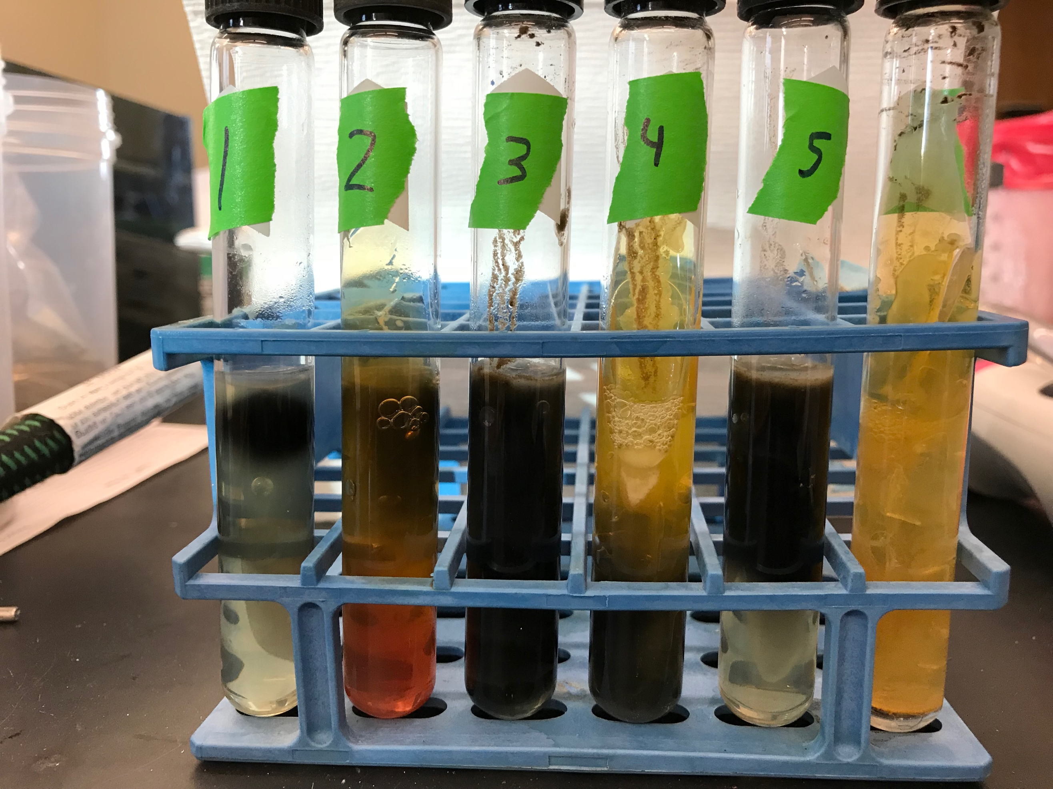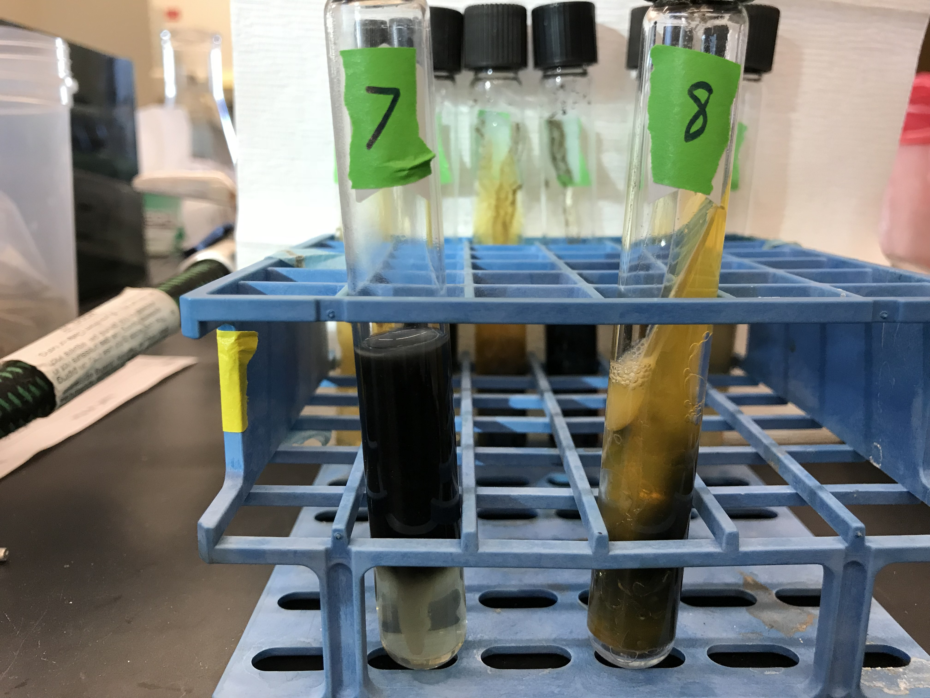 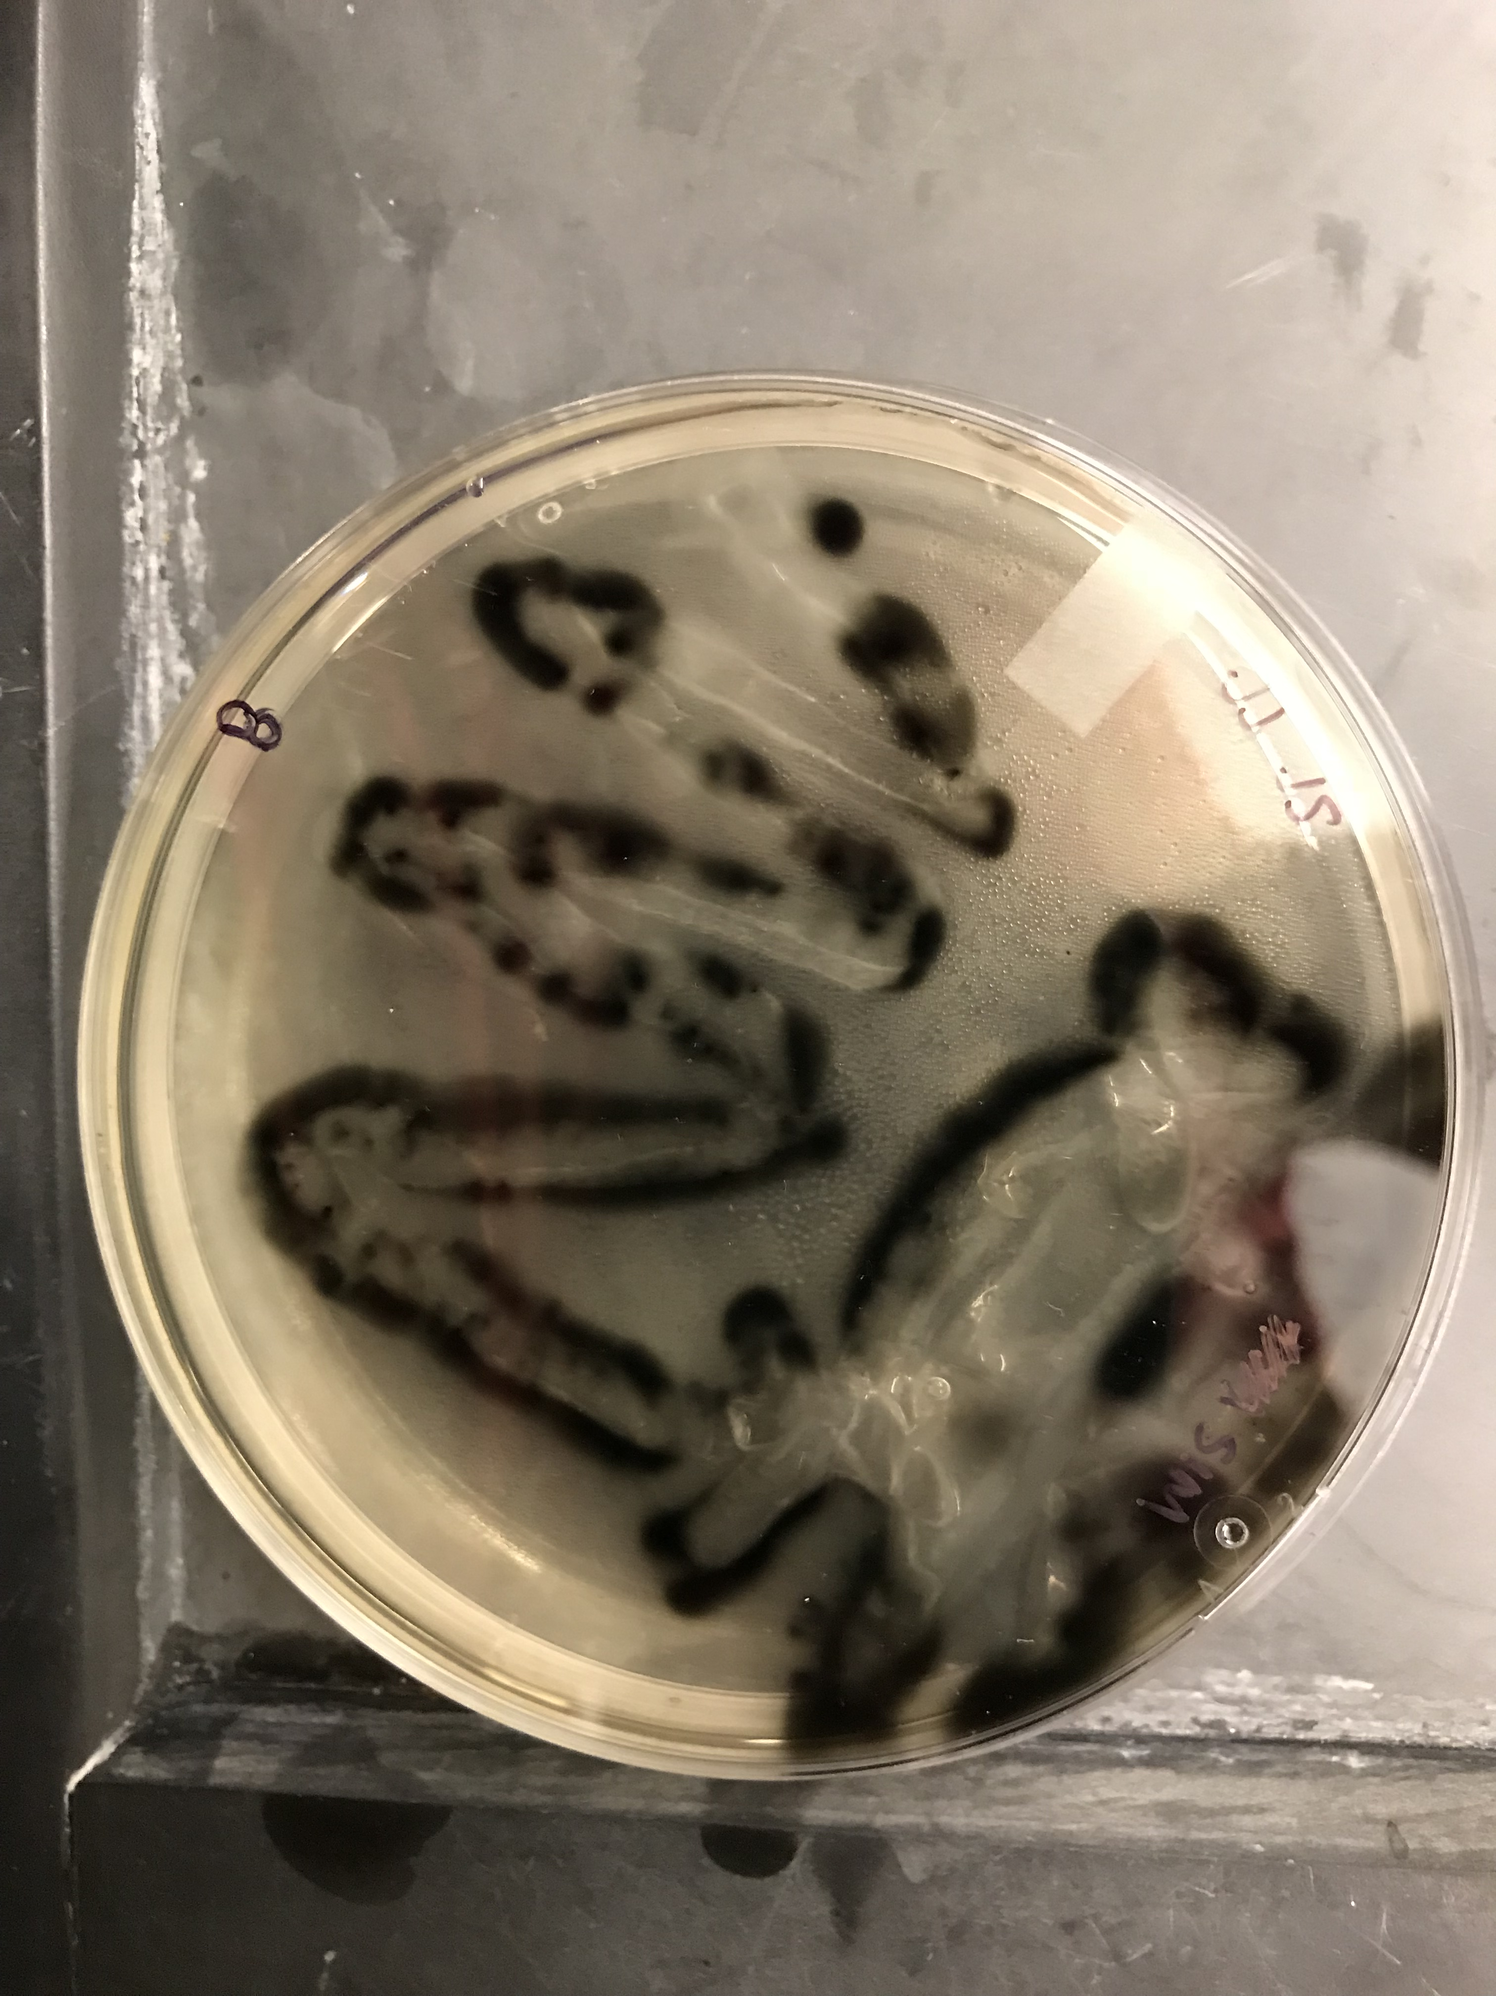

**A**

**B**

**Figure 2- SIM and TSI Inoculation of Winogradsky Column Enrichments.**

**A.** SIM (tube 5) and TSI (tube 8) were inoculated with soil bacteria enriched for SRB. Hydrogen sulfide production was indicated by the precipitation of the black ferric sulfide, which formed in both aerobic zones (green arrows) as well as anaerobic zones (red arrows). Gas production, likely gas from sugar fermentation with a small amount of unprecipitated hydrogen sulfide, was observed in TSI cultures but not SIM. Motility was evident from the formation of the precipitates away from the central stab line.

**B.** Putative SRB cultures were streaked for isolation on SIM plates and formed black colonies.

as shown in the last column of Table 1, suggesting successful isolation of SRB.

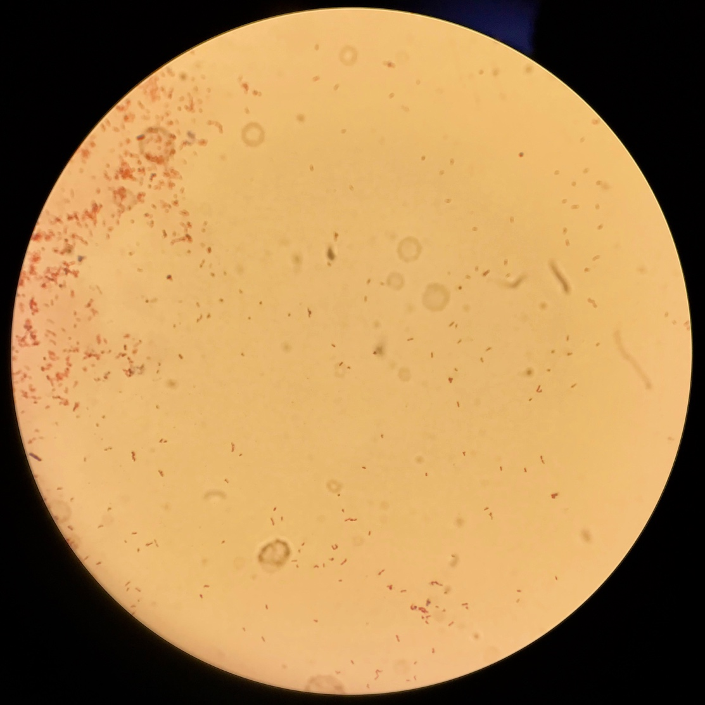Although SRB growth on SIM and TSI media was successful, SRB were unable to be cultured under other conditions.  Supplementing enriched media, such as lysogeny broth (LB; BD Difco) or tryptic soy agar (TSA; BD Difco), with iron sulfate and a preferred carbon source like lactate or ethanol did not produce any growth of SRB.  Additionally, thioglycolate broth (Difco Bacto), a medium containing reducing agents to remove oxygen and generate anoxic conditions below the surface, did not support the growth of SRB when supplemented similarly (Figure 4).

**Figure 3- Gram Stain of SRB**

Isolated cultures of SRB were confirmed to be gram negative. Most cultures possessed a rod morphology with primarily singlet or doublet organization.

**DISCUSSION**

SRB were successfully isolated from a sample of pond sediment, as the isolated bacteria share all of the characteristics of typical SRB. The first step in the isolation of SRB was enrichment in a Winogradsky column that generated proper nutrient conditions to grow SRB in the bottom zone of sediment. In subsequent cultures, only anaerobically growing hydrogen sulfide producers were selected for isolation and further evaluation. Although hydrogen sulfide production is a defining characteristic of SRB, further tests were carried out to confirm the presence of other typical SRB characteristics. Isolated SRB were strictly anaerobic and were determined to not contain catalase, an enzyme responsible for the conversion of toxic hydrogen peroxide to water and oxygen to protect the cell from oxidative damage. Strict anaerobes do not typically encode catalase as the presence of toxic environmental oxidizing compounds is limited.

This method of isolating SRB from enrichment culture differs from methods commonly found in the literature. Many researchers (13, 14, 15)have grown SRB from environmental sources on enriched media supplemented with  iron sulfate and a preferred carbon source, typically lactate or acetate. We were unsuccessful in cultivating SRB on solid LB or TSA with these supplements as well as in supplemented thioglycolate broth.  It is possible that SRB were outcompeted in liquid culture by facultative anaerobic organisms from the soil samples that could utilize the oxic zone atop the broth as well as the lower anoxic regions.  Shukla and Reed also claim that SRB growth in broth medium is not a recommended method of isolation because a change in optical density does not occur for a number of days (1). During the preparation of solid media, we also noticed that solutions of iron frequently generated gray precipitates of ferric iron compounds when filter sterilized into media at 50˚ C, possibly precipitating with an essential anion and therefore removing it from availability.  Furthermore, solid iron compounds may demonstrate oligodynamic properties, inhibiting the growth of certain microbes (16) and accounting for the slow and reduced growth of all organisms on media containing traces of precipitated iron.

Nevertheless, the present method of sampling the Winogradsky columns proved to be effective at isolating similar hydrogen sulfide producing colonies as isolated by Iverson (17) using complex media. This method was effective because enriching for SRB prior to isolation avoided a main challenge for previous SRB isolation in the literature, ensuring that SRB were not outcompeted by other organisms. Therefore, 3% NaSO3·7H2O was not required to inhibit the growth of competing organisms, as proposed by Butlin, Adams, and Thomas (6).

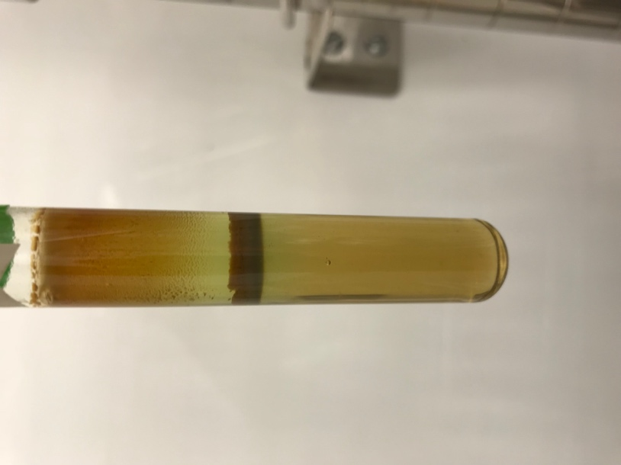The identification and isolation of SRB using iron sulfide as a marker of growth suggests that detection of SRB contamination is a straightforward process. Therefore, future research should prioritize cost-efficient decontamination methods over diagnostic methods. This updated focus of research could assist in the efficiency of SRB remediation efforts considering the vast cost of these methods. Furthermore, the increased understanding of the requirements of SRB produced by this work in terms of the range of their preferred growth conditions may facilitate the establishment of laboratory culture conditions for diverse SRB. The ability to culture many types of SRB under laboratory conditions is requisite for the development of broad-spectrum SRB removal methods because it will both provide information about essential compounds for SRB inhibition as well as allow efficient experimentation.  Future research will seek to develop broadly acting anti-SRB compounds that are both cost effective and biologically efficient, reducing the economic burden of SRB on municipal and industrial machinery and increasing the productivity of many modern processes from wastewater treatment to oil extraction.

**ACKNOWLEDGEMENTS**

**Figure 4- Supplemented Thioglycolate Broth did not Support SRB Growth**

Soil samples were used to inoculate thioglycolate broth supplemented with lactate and iron sulfide. While organisms in the oxic and microaerophilic region grew, including a pellicle biofilm that sunk when gently disturbed (dark band in middle), there is no evidence of SRB growth or the characteristic black precipitate.

The authors would like to acknowledge the contributions of Tim Allen, who provided the samples used to isolate SRB as well as many reagents necessary for their cultivation; Dr. Grace Spatafora, who aided in the conception of isolation techniques; and the rest of the BIOL310 class.

**LITERATURE CITED**

1. **Shukla SK, Reed KD.** 2000. Desulfovibrio desulfuricans bacteremia in a dog. J Clin Microbiol 38:1701.

2. **Willis CL, Gibson GR, Allison C, Macfarlane S, Holt JS.** 1995. Growth, incidence and activities of dissimilatory sulfate-reducing bacteria in the human oral cavity. FEMS Microbiol Lett 129:267–271.

3. **van der Hoeven J, van den Kieboom C, Schaeken M.** 1995. Sulfate‐reducing bacteria in the periodontal pocket. Oral Microbiol Immunol 288–290.

4. **Gibson.** 1990. A Review: Physiology and Ecology of the Sulphate-Reducing Bacteria. J Appl Bacteriol 769–797.

5. **Barton LL.** 1995. Sulfate-Reducing Bacteria. Springer US, Boston, MA.

6. **Butlin KR, Adams ME, Thomas M.** 1949. The isolation and cultivation of sulphate-reducing bacteria. Microbiology 3:46–59.

7. **Overmann J, Gemerden H.** 2000. Microbial interactions involving sulfur bacteria: implications for the ecology and evolution of bacterial communities. FEMS Microbiol Rev 24:591–599.

8. **Luptakova A.** 2007. Importance of sulphate-reducing bacteria in environment. Nova Biotechnol 7:17–22.

9. **Hamilton WA.** 1985. Sulphate-reducing bacteria and anaerobic corrosion. Annu Rev Microbiol 39:195–217.

10. **Enning D, Garrelfs J.** 2014. Corrosion of Iron by Sulfate-Reducing Bacteria: New Views of an Old Problem. Appl Environ Microbiol 80:1226–1236.

11. **Allen T, Spatafora G.** 2017. BIOL 310: General Microbiology Laboratory Manual, Twelfth Edition.

12. **Bergey D, Krieg N, Holt J.** 1984. Bergey’s Manual of Determinative Bacteriology.

13. **Keith SM, Herbert RA, Harfoot CG.** 1982. Isolation of new types of sulphate-reducing bacteria from estuarine and marine sediments using chemostat enrichments. J Appl Microbiol 53:29–33.

14. **Muyzer G, Stams AJM.** 2008. The ecology and biotechnology of sulphate-reducing bacteria. Nat Rev Microbiol.

15. **Postgate J.** 1959. Differential Media for Sulfur Bacteria. J Sci Food Agric 669–674.

16. **Khan MR, Saha ML, Begum N, Islam MN, Hoque S.** 2010. Isolation and characterization of bacteria from rusted iron materials. Bangladesh J Bot 39:185–191.

17. **Iverson WP.** 1966. Growth of Desulfovibrio on the surface of agar media. Appl Microbiol 14:529–534.